
物業名稱
XXXX年度客戶服務問卷調查結果

為了貫徹我們的宗旨，實踐「致力提升生活質素」的承諾，我們已於XXXX年X月進行全面的業戶意見調查，讓我們更瞭解您們的需要，提供更稱心的服務。我們非常感謝您們抽出寶貴的時間完成 2019年度物業名稱客戶服務問卷，現簡報結果分析如下：

意見調查日期： | dd/mm/yyyy | 至 | dd/mm/yyyy

發出問卷數目(份) | 收回有效問卷數量 (份) | 回應百份率 | 廢票 (份)
X | X | X % | X

2019年管理服務水平
整體滿意率: X % | 各範疇整體表現結果分析：
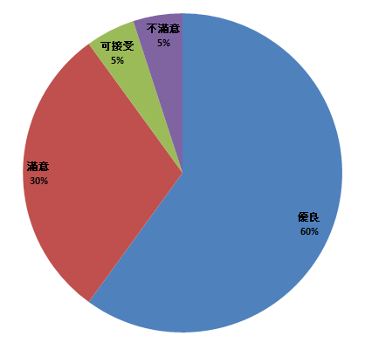 | 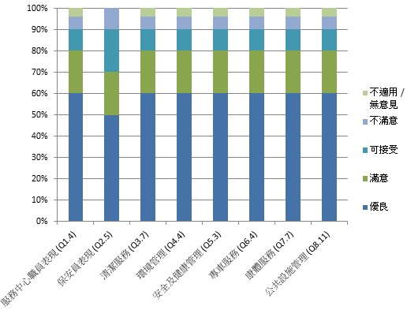

綜合您們的意見建議，我們已進行下列改善措施及訂下優化計劃：

Text / photo to be filled by user

如對上述事宜有任何查詢，歡迎致電XXXX XXXX與服務中心職員聯絡。

Property Name
Result of Customer Satisfaction Survey XXXX

In order to have a further understanding of your needs and enhance our services, we have conducted an annual customer survey in Month-Year. Thank you for your valuable time on completing the survey and the result is summarized as below:

Survey Period: | dd/mm/yyyy | to | dd/mm/yyyy

Questionnaire Distributed (nos.) | Questionnaire Received (nos.) | Response Rate | Invalid questionnaire (nos.)
X | X | X % | X

Performance on Management Service 2019
Overall Satisfactory Rate : X % | Overall Performance of Different Sections:

The following improvement actions have been taken and planned to carry out:

Text / photo to be filled by user

Should you have any enquiries, please contact the Service Centre on XXXX XXXX.

